**Customer Mapping and Analysis**

To build an effective flyer distribution campaign we start with mapping of customer data for all existing stores. This shows us where your customers come from and identifies the areas that we should focus on when distributing flyers.

The following map shows each customer point mapped by their street address or postal code. This gives us a detailed view of customer locations and how they are distributed around your stores.

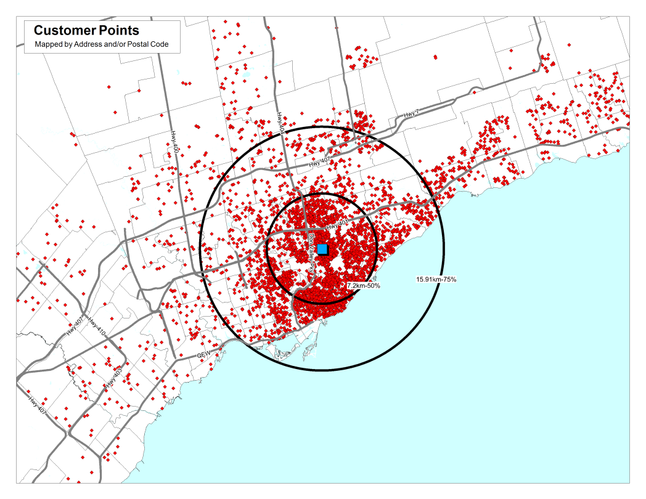

We then create a thematic map by FSA which provides a graphic view of the highest potential areas. In the example below we see how all of the customer points are aggregated by FSA. We can see very quickly that there are 18 FSAs around the sample store that have 100 plus customers.

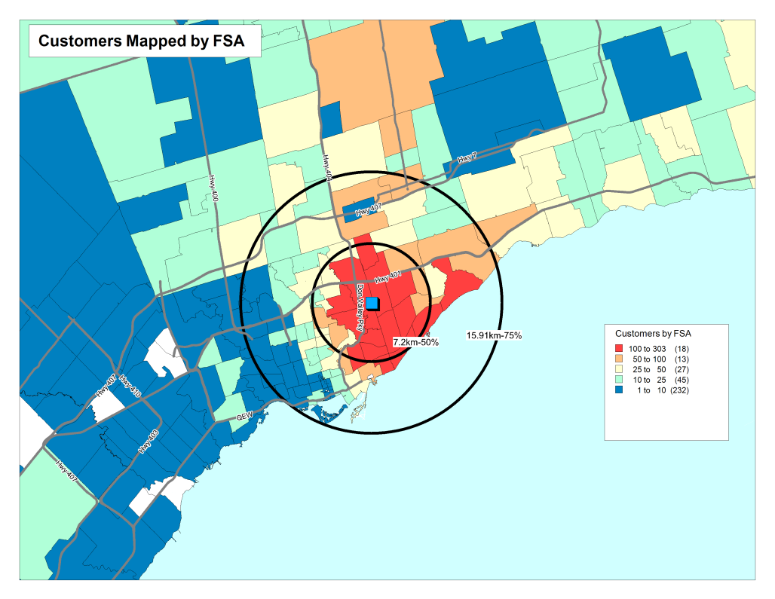

Another way to visualize customer data is by creating a density distribution, or heat map. This shows the areas of highest concentration as they occur on the ground. This helps to better interpret a large number of dots representing individual customer households.

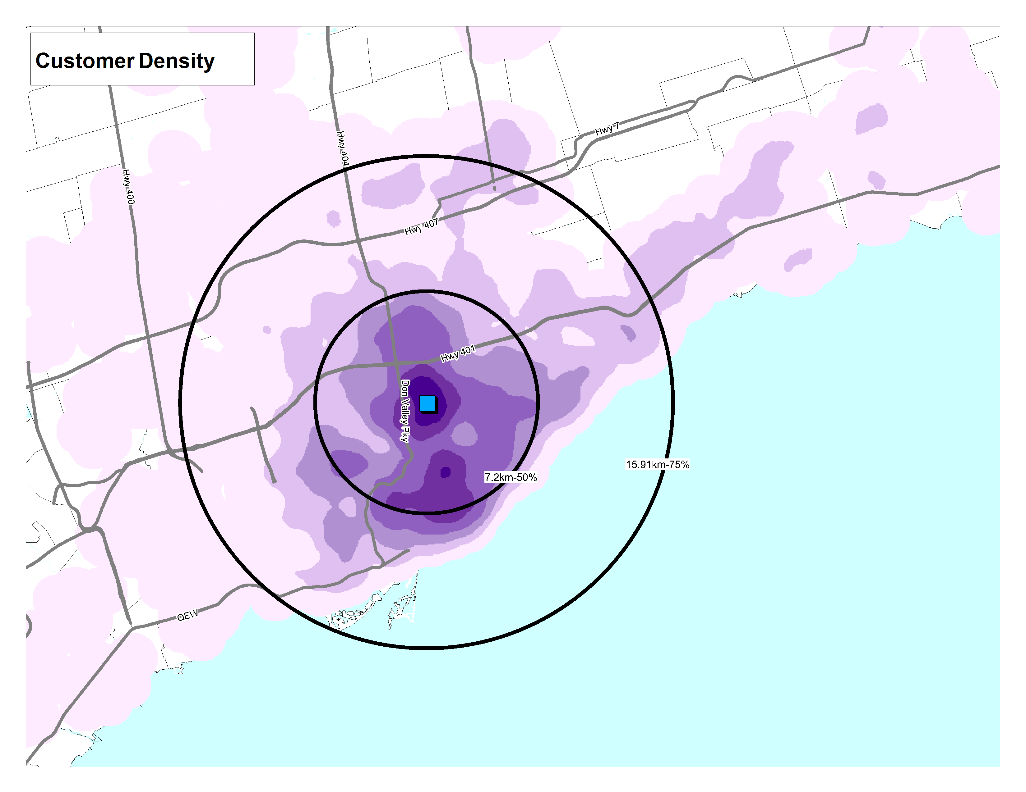

The Excel table below shows a sample FSA list with the number of customers in each, along with the penetration percentage.



From the customer data we can also extract demographic profiles that will provide a description of the types of households that you currently draw from – including average household income, household size, age, education, employment and types and values of dwellings. The Sample Report below shows a small selection of the demographic variables available.

